Experiment 7

Aim: - To create a file transfer program using FTP protocol.

Steps for server: -

1. We import socket module which helps in establishing the client/server communication. Import OS.
2. Bind the host from the port address so that a proper connection can be established between the client and server.
3. Create a text file say ‘cliento.txt’ and add some text in it which is required to be transferred in another file.
4. Use os package to open the file,read it, copy it and send it to the another file.
5. Close the server.

Steps for Client: -

1. We import socket module which helps in establishing the client/server communication. Import OS.
2. Connect the client with server using connect function and using the same ip address and port address.
3. Receive the file, write it in the new file and display it after closing the client.
4. Check the new file created.

Code for Server:-

**import** socket  
  
**import** os  
  
port = 6000  
s = socket.socket()  
host = **'127.0.0.1'**s.bind((host, port))  
s.listen(5)  
  
  
**while True**:  
 conn, addr = s.accept()  
 filename = **'cliento.txt'** b = os.path.getsize(filename)  
 f = open(filename, **'rb'**)  
 l = f.read(b)  
  
 **while** (l):  
 conn.send(l)  
  
 l = f.read(b)  
 f.close()  
  
 print(**'Done sending'**)  
 conn.close()

Code for Client:-

**import** socket  
**import** os  
  
s = socket.socket()  
host = **'127.0.0.1'**port = 6000  
s.connect((host, port))  
  
**with** open(**'received_file1'**, **'wb'**) **as** f:  
 **while True**:  
  
 data = s.recv(1024)  
  
 f.write(data)  
  
 **if not** data:  
 **break** d = os.path.getsize(**'received_file1'**)  
print(data)  
print(d)  
f.close()  
print(**'Successfully received the file'**)  
s.close()  
print(**'connection closed'**)

Console Screenshots : -

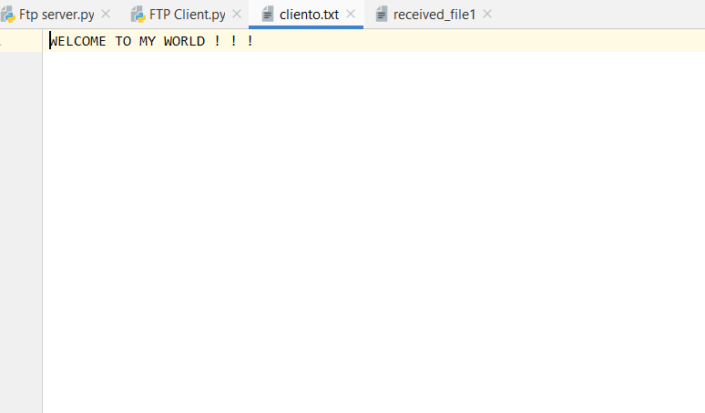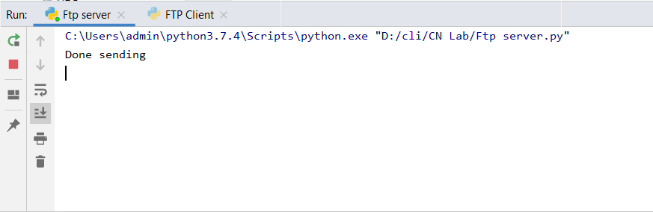1)The file which needs to be copied and server console : -

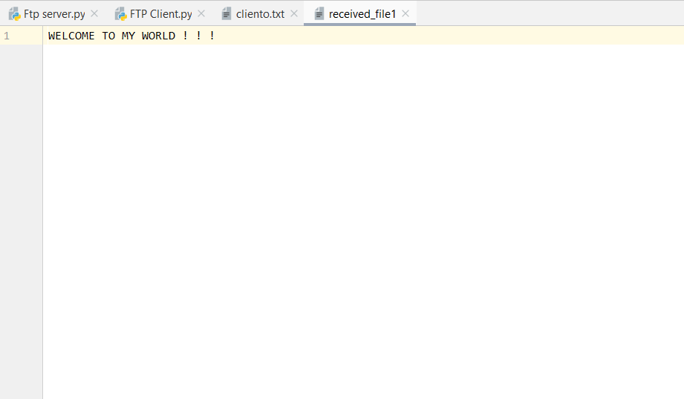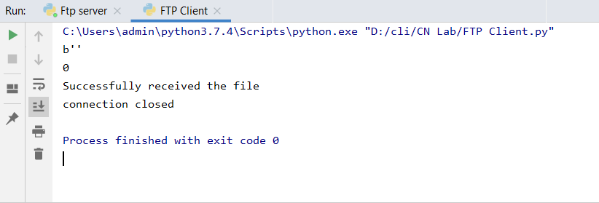2)Client console and received file : -

Result : - Successful file transfer was done using the File transfer protocol.